# Oil Spill Detection using Deep Learning Techniques

This document provides a comprehensive overview of the Oil Spill Detection project, emphasizing its methodology, dataset structure, model architecture, evaluation metrics, and results. The approach aims to deliver a reliable and effective solution for detecting oil spills in various environmental conditions through the utilization of machine learning models.

## Table of Contents

1. Abstract  
2. Introduction  
3. Related Work  
4. Methodology  
5. Dataset  
6. Preprocessing  
7. Model Architecture  
8. Evaluation Metrics  
9. Results  
10. Conclusion

## Abstract

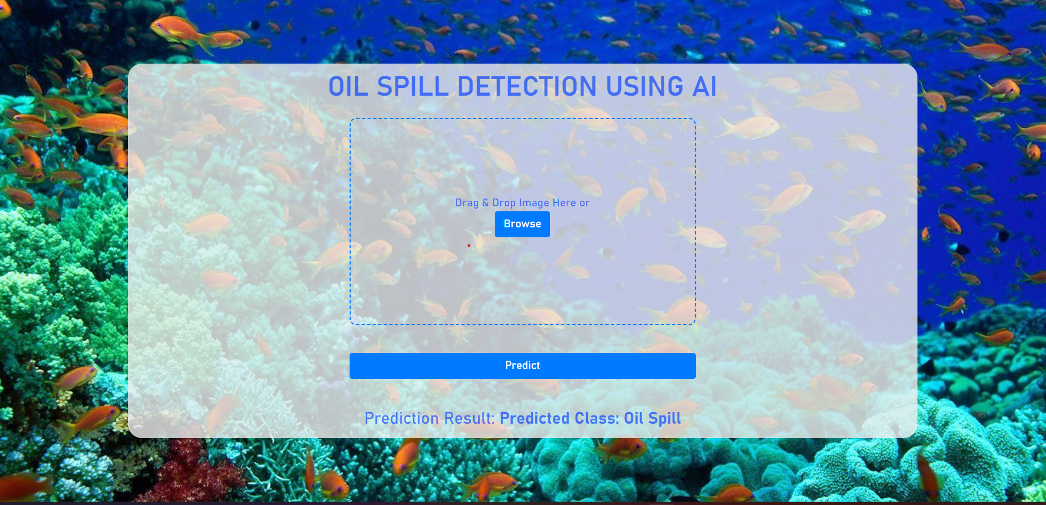This project leverages deep learning techniques to detect oil spills in diverse environments. The approach includes an experimental setup using convolutional neural networks (CNNs) for feature extraction and classification. The results demonstrate high accuracy and robustness in various tests.

## Introduction

Oil spills pose a significant environmental risk, impacting marine and coastal ecosystems. Current detection methods are often costly and lack automation. This project explores an AI-driven solution that automates oil spill detection in images. The objective is to provide a scalable and reliable model capable of detecting oil spill events in diverse scenarios.

## Related Work

Numerous studies have utilized deep learning to identify patterns in environmental data, but few have focused on oil spill detection. Techniques such as CNNs, ResNet, and transfer learning have proven effective in similar image classification tasks. This project builds on previous research by enhancing the model's feature extraction capabilities.

## Methodology

The methodology consists of data acquisition, preprocessing, model design, training, and evaluation. The CNN model is structured to extract essential features, with tuning to maximize detection accuracy while minimizing false positives.

## Dataset

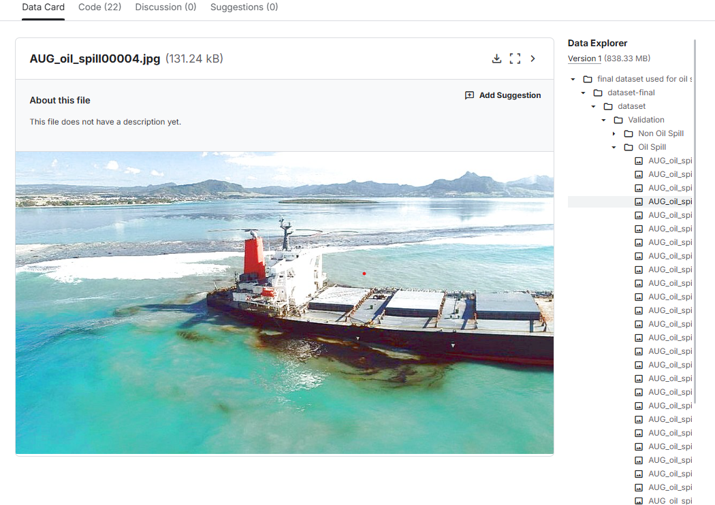The dataset comprises images from various marine environments, manually labeled as either oil-spill or non-oil-spill. The data is split into training, validation, and test sets to ensure robustness.

## Preprocessing

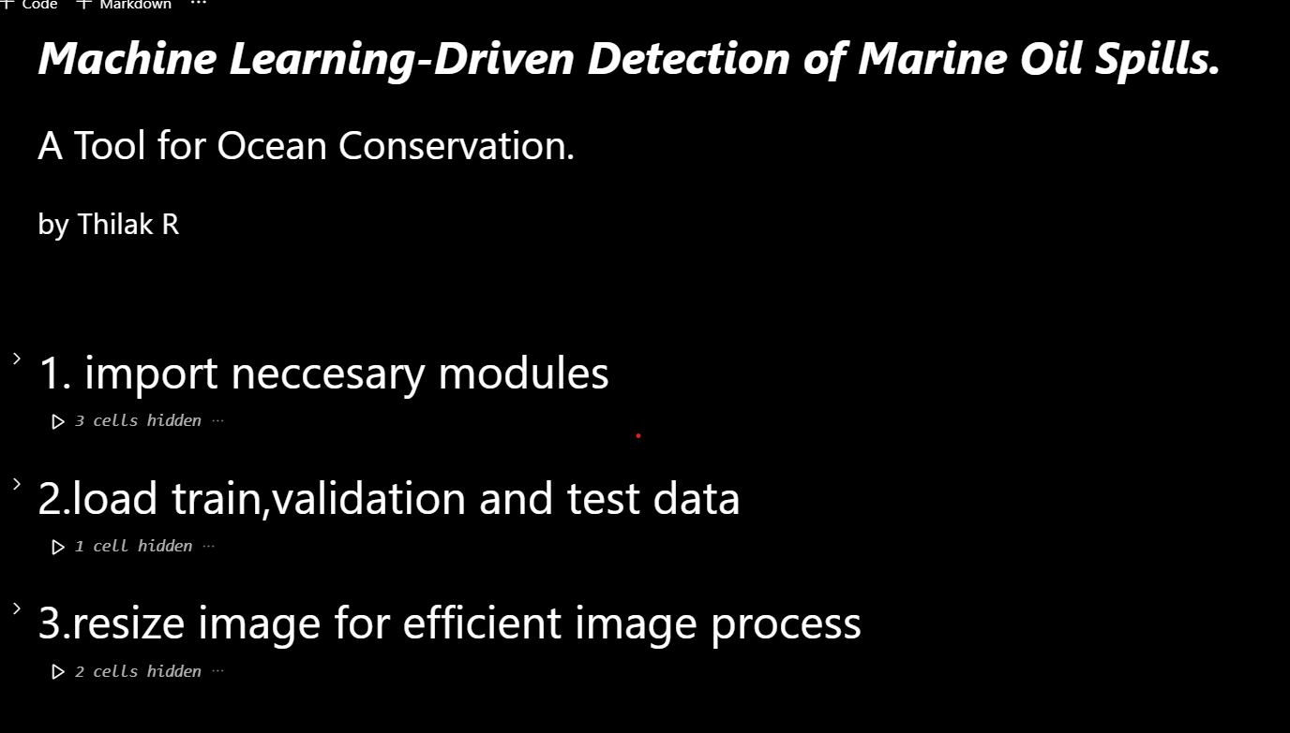Preprocessing involves resizing images, normalizing pixel values, and applying augmentations such as rotations and flips to improve model generalization. This step is essential for enhancing feature learning.

## Model Architecture

The model employs a convolutional neural network (CNN) for feature extraction. The architecture includes several convolutional layers, pooling layers, and dense layers. A final softmax layer outputs the probability of an oil spill being present in the image.

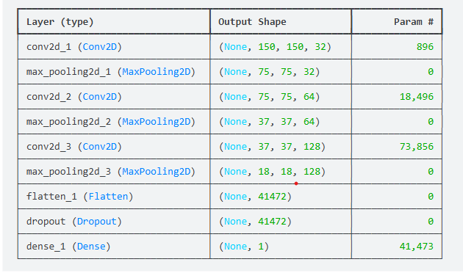

## Evaluation Metrics

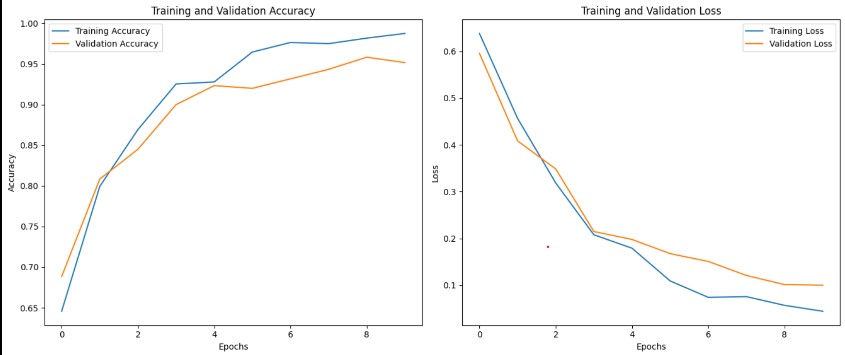To assess model performance, accuracy, precision, recall, F1 score, and AUC-ROC are used. These metrics offer a comprehensive understanding of the model’s efficacy in detecting oil spills.

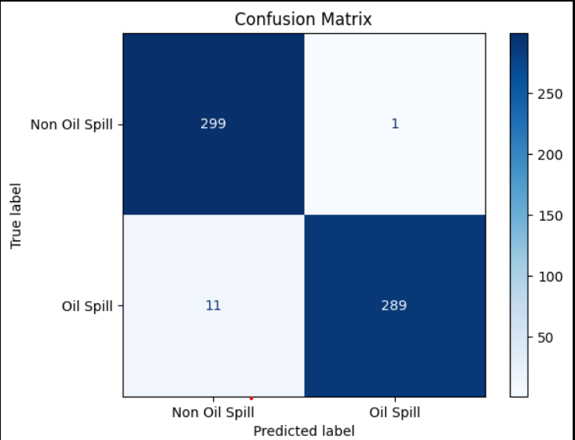

## Results

The model achieved high accuracy and precision, demonstrating its effectiveness in real-world scenarios. The confusion matrix and ROC curve highlight the model’s ability to minimize false positives and maintain robust detection across different environments.

## Conclusion

This project showcases a promising approach to automated oil spill detection. By leveraging CNNs, the model successfully identifies oil spill patterns in diverse images, with potential applications in environmental monitoring and disaster management. Future work may focus on integrating the model with real-time monitoring systems and expanding the dataset.